ONLINE AUCTION AND BIDDING SYSTEM
Abstract
The Online Auction and Bidding System is a console-based Java application that simulates a real-world auction platform where multiple bidders can place bids on listed items. The system allows users to register items for auction, view available items, place bids, and determine the highest bidder. It demonstrates core Java programming concepts such as data types, control flow (selection and iteration), methods, recursion, and arrays (1-D and 2-D). The project provides a simple, menu-driven interface that helps users interact with the auction system efficiently while maintaining bid records and identifying winning bids.
Advantages
- Automated Bidding Process – Eliminates manual record keeping and reduces errors.
- Transparency – All bids are recorded and visible to users.
- Time Efficient – Multiple items and bidders can be managed from a single interface.
- Accurate Winner Detection – The highest bidder is determined automatically.
- Scalable Design – New features like categories, timers, or user login can be easily added.
- Educational Value – Demonstrates Java fundamentals (data types, control flow, methods, recursion, arrays).
CODE:
// OnlineAuctionSystem.java
// Combined implementation of CO1, CO2, CO3

import java.util.Scanner;

public class OnlineAuctionSystem {

// ---------- CO1: Data Types & Data Storage ----------
static final int MAX_ITEMS = 5;
static final int MAX_BIDS = 10;

static int[] itemIds = new int[MAX_ITEMS]; // 1-D Array (int)
static String[] itemNames = new String[MAX_ITEMS]; // 1-D Array (String)
static double[] basePrices = new double[MAX_ITEMS]; // 1-D Array (double)
static boolean[] isActive = new boolean[MAX_ITEMS]; // 1-D Array (boolean)
static double[][] bids = new double[MAX_ITEMS][MAX_BIDS]; // 2-D Array
static int[] bidCount = new int[MAX_ITEMS]; // bids per item
static int itemCount = 0;

static Scanner sc = new Scanner(System.in);

// ---------- CO3: Method to Register Item ----------
static void registerItem() {
if (itemCount >= MAX_ITEMS) {
System.out.println(">> Item limit reached!");
return;
}

System.out.print("Enter Item ID (int) : ");
itemIds[itemCount] = sc.nextInt();
sc.nextLine(); // consume newline

System.out.print("Enter Item Name (String) : ");
itemNames[itemCount] = sc.nextLine();

System.out.print("Enter Base Price (double) : ");
basePrices[itemCount] = sc.nextDouble();

System.out.print("Is item active? (true/false): ");
isActive[itemCount] = sc.nextBoolean();

bidCount[itemCount] = 0;
itemCount++;

System.out.println(">> Item registered successfully!");
}

// ---------- CO3: Method to Display Items (uses CO2 for-loop) ----------
static void displayItems() {
if (itemCount == 0) {
System.out.println(">> No items available.");
return;
}

System.out.println("\n----- Available Auction Items -----");
System.out.printf("%-5s %-6s %-20s %-12s %-10s%n",
"No.", "ID", "Name", "Base Price", "Active");
System.out.println("----------------------------------------------------------");

for (int i = 0; i < itemCount; i++) {
System.out.printf("%-5d %-6d %-20s %-12.2f %-10s%n",
(i + 1), itemIds[i], itemNames[i], basePrices[i], isActive[i]);
}
}

// ---------- CO3: Method to Get Highest Bid ----------
static double getHighestBid(int idx) {
double highest = basePrices[idx];
for (int i = 0; i < bidCount[idx]; i++) {
if (bids[idx][i] > highest) {
highest = bids[idx][i];
}
}
return highest;
}

// ---------- CO3: Recursive Method to Sum All Bids ----------
static double sumBids(int itemIdx, int bidIdx) {
if (bidIdx >= bidCount[itemIdx]) { // base case
return 0;
}
return bids[itemIdx][bidIdx] + sumBids(itemIdx, bidIdx + 1); // recursive call
}

// ---------- CO2 + CO3: Place Bid with Validation ----------
static void placeBid() {
displayItems();
if (itemCount == 0) return;

System.out.print("\nSelect item number: ");
int idx = sc.nextInt() - 1;

// CO2: Selection (if-else) for validation
if (idx < 0 || idx >= itemCount) {
System.out.println(">> Invalid item number!");
return;
}

if (!isActive[idx]) {
System.out.println(">> This item is not active for bidding.");
return;
}

if (bidCount[idx] >= MAX_BIDS) {
System.out.println(">> Bid limit reached for this item.");
return;
}

System.out.print("Enter your bid amount: ");
double amount = sc.nextDouble();

double highest = getHighestBid(idx);

// CO2: Selection with nested conditions
if (amount <= basePrices[idx]) {
System.out.println(">> Bid must be at least the base price: " + basePrices[idx]);
} else if (amount <= highest && bidCount[idx] > 0) {
System.out.println(">> Bid too low. Current highest is: " + highest);
} else {
bids[idx][bidCount[idx]] = amount;
bidCount[idx]++;
System.out.println(">> Bid placed successfully! You are now the highest bidder.");
}
}

// ---------- CO3: Show Detailed Results (uses recursion) ----------
static void showResults() {
if (itemCount == 0) {
System.out.println(">> No items to display.");
return;
}

System.out.println("\n=========== AUCTION RESULTS ===========");
for (int i = 0; i < itemCount; i++) {
System.out.println("Item ID : " + itemIds[i]);
System.out.println("Item Name : " + itemNames[i]);
System.out.println("Base Price : " + basePrices[i]);
System.out.println("Highest Bid : " + getHighestBid(i));
System.out.println("Total Bids : " + bidCount[i]);
System.out.println("Sum of Bids : " + sumBids(i, 0)); // recursion
System.out.println("---------------------------------------");
}
}

// ---------- CO3: Search Item by ID ----------
static int searchItemById(int id) {
for (int i = 0; i < itemCount; i++) {
if (itemIds[i] == id) return i;
}
return -1;
}

static void searchMenu() {
System.out.print("Enter Item ID to search: ");
int id = sc.nextInt();
int idx = searchItemById(id);

if (idx == -1) {
System.out.println(">> Item not found.");
} else {
System.out.println(">> Item Found: " + itemNames[idx] +
" | Base Price: " + basePrices[idx] +
" | Highest Bid: " + getHighestBid(idx));
}
}

// ---------- CO2: Main Menu with do-while loop ----------
public static void main(String[] args) {

System.out.println("==========================================");
System.out.println(" WELCOME TO ONLINE AUCTION & BIDDING ");
System.out.println("==========================================");

int choice;

do {
System.out.println("\n============= MAIN MENU =============");
System.out.println("1. Register New Item");
System.out.println("2. View All Items");
System.out.println("3. Place a Bid");
System.out.println("4. Search Item by ID");
System.out.println("5. Show Auction Results");
System.out.println("6. Exit");
System.out.print("Enter your choice: ");
choice = sc.nextInt();

switch (choice) {
case 1: registerItem(); break; // CO1 + CO3
case 2: displayItems(); break; // CO2 + CO3
case 3: placeBid(); break; // CO2 + CO3
case 4: searchMenu(); break; // CO3
case 5: showResults(); break; // CO3 (recursion)
case 6: System.out.println("\n>> Thank you for using the Auction System!");
break;
default: System.out.println(">> Invalid choice! Try again.");
}

} while (choice != 6); // CO2: iteration

sc.close();
}
}

OUTPUT:
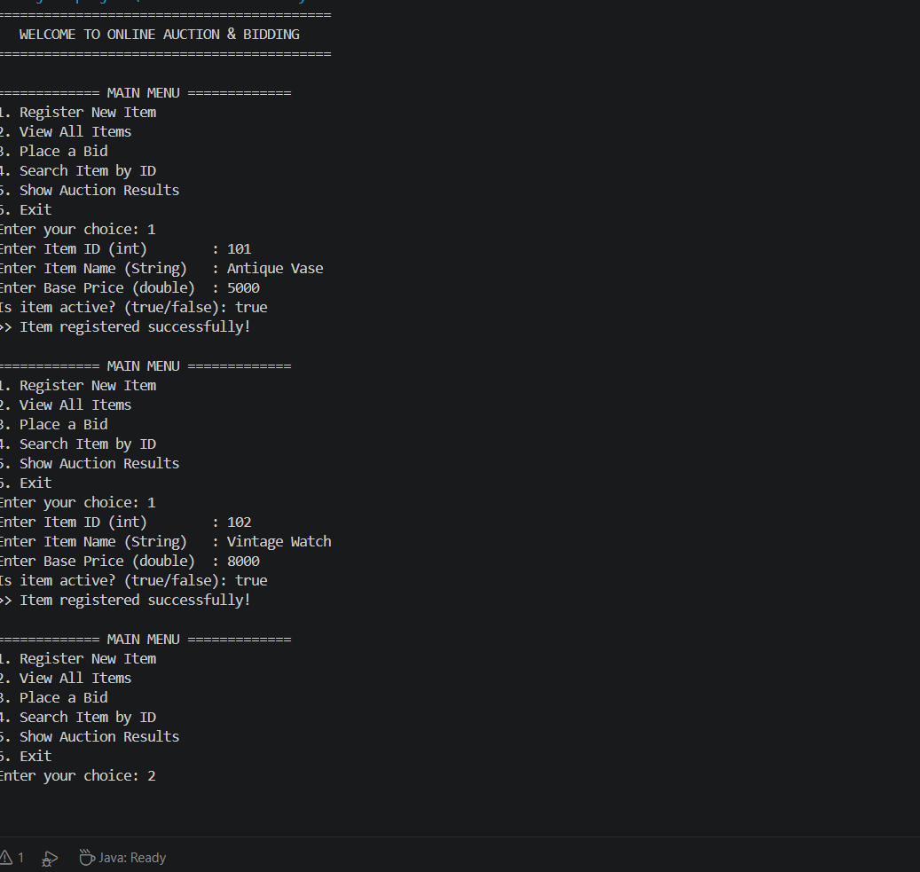

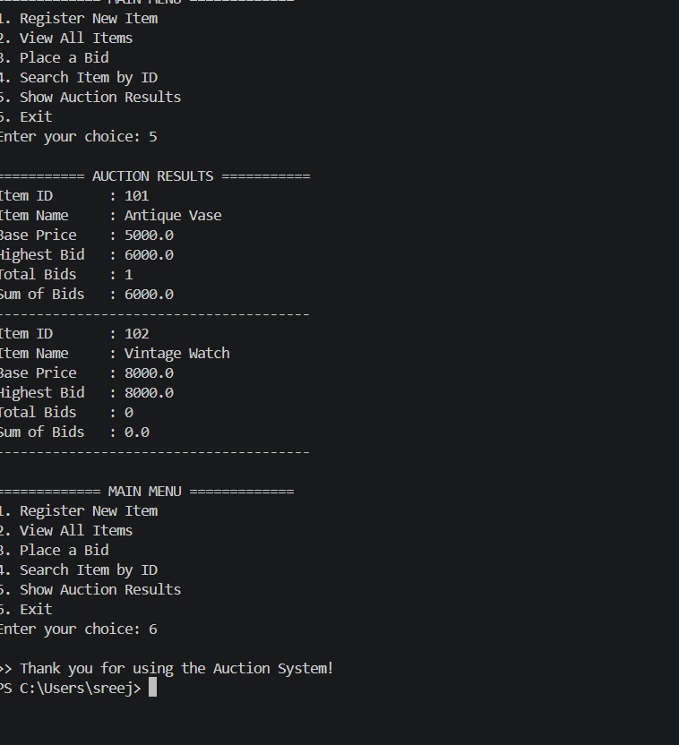

Conclusion
This combined implementation of the Online Auction and Bidding System successfully integrates all three Course Outcomes into a single, cohesive Java application. CO1 established the foundation using appropriate data types and input/output. CO2 implemented decision-making and repetition through if-else, switch, do-while, and for loops to control the auction workflow. CO3 organized logic into reusable methods, demonstrated recursion via sumBids(), and used 1-D and 2-D arrays to store items and their bids efficiently. The result is a fully functional auction simulation that is both educational and extensible, forming a solid base for future enhancements such as file storage, user authentication, or GUI implementation.

